**W . O . N**

**Watch Out Now**



2022 RETREAT

Hosted by Waxahachie Womens Group

April 29th – May 1st

Lake Whitney, Texas

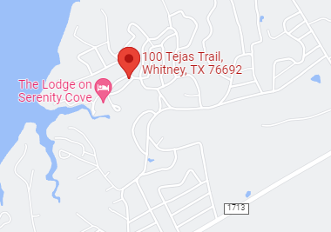

<https://www.thelodgeonserenitycove.com>

(254)694-7839***Contact the Lodge for additional cabin availability.

SCHEDULE OF EVENTS

Subject to change

Friday April 29th

3pm…………………………………………………………….. Check-in

5:30pm…………………………………………………Meet & Greet

6:30pm……………………………………………….. Dinner break

8:00pm…………………………………………. Speaker Meeting

Saturday April 30th

8:00am……………………………………………………….. Breakfast

10:00am……………………………………………….. Meeting (TBA)

11:30am………………………………………………………………. Lunch

1:00pm……………………………………………………….. Craft Hour

3:00pm…………………………………………………………… Meeting

4:00pm………………………………………………………. Free Time

5:00pm---------------------Speaker Meeting

6:00pm……………………………………………………………… Dinner

8:00pm……………………………………………………………. Meeting

10pm………………………………………… Candlelight Meeting

Sunday May 1st

8am……………………………………………………………… Breakfast

9am…………………………… Walk to Serenity or Meeting

11am…………………………………………………………….. check-out



***REGISTRATION BY PHONE ONLY***

**Kym 469-834-3193 or Kelly 703-300-8438**

$60 Group Lodging – *Limited space available*

Cost includes 2 nights, 2 breakfast & Saturday Lunch (Non-Refundable) Dinner Friday & Saturday night is NOT included but they have restaurants nearby and at the lodge.

$30 3-Day Pass Only (Fri, Sat, Sun) You can call the lodge for cabins.

$15 1 Day Pass

$12 T-shirt – please indicate size went registering

$___ Scholarship donation

**Scholarships are for those that would like to go but unable due to financial restraints.

Payments through Venmo-Business@

waxahachiewomenretreat_2022

Please use your name in the memo

***Water & Coffee will be provided

Bring your own snacks, swimming towels

***Contact the Lodge for additional cabin availability.