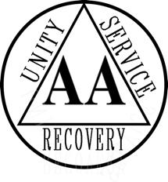

**Come Celebrate**

**New Location**

**Sunday, September 5, 2021**

**12:00 PM – 3:00 PM**

**Hosted by The Lewisville Group**

**1305 S. State Hwy 121**

**Lewisville, TX 75067**

**972-436-4516**

**Food, Fun and Fellowship**